Move left image on Home page to Contact page . Only left image , join it with Thank you for Visiting us ……..



Home Page banner
Replace with current image on the left handside only , remove the 2 persons and join with ROAR ….

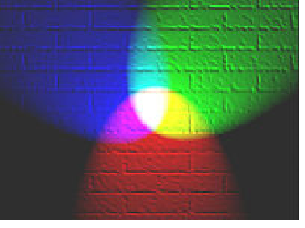

Team Reflective banner
Replace with left image and join with TEAM image ……


Team Reflective Page
Right hand side , replace 3 persons images

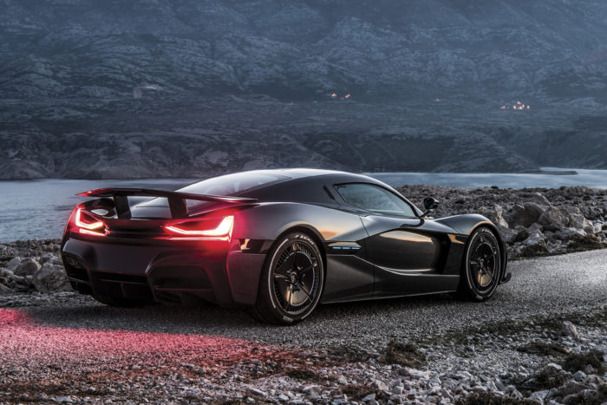

Replaces construction vehicle image


